Christina Vona
GeoGebra Lesson: Discovering Similar Triangles
Grades: 6-8

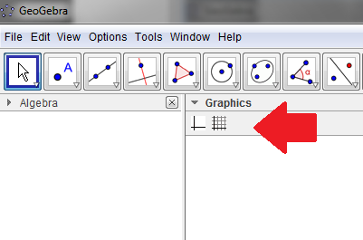
- On the main screen, click on graphics and select the grid and unselect the axis.

- Next, click the arrow on polygon, the fourth square from the left, and select the first option polygon.
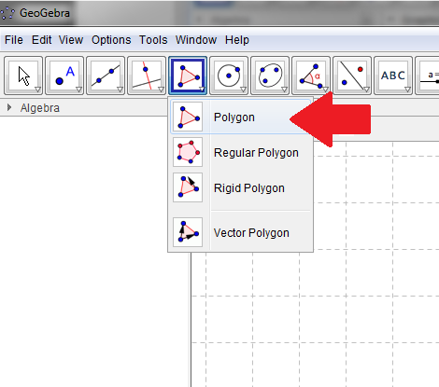
- Click anywhere on your grid to create a point A, a point B, and a point C. (Keep the triangle relatively small) Make sure to connect point C to point A to create the triangle.

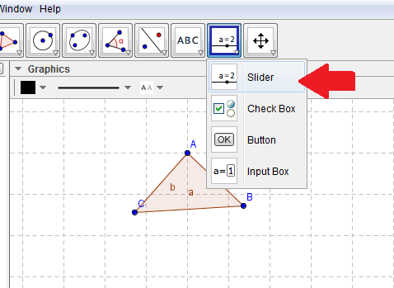
- Click the arrow on slider, the second square from the right, and select the first option slider.

- Click anywhere on the grid next to your triangle and the slider box will appear. Change the name to scale, make the minimum interval 0, the maximum 3, and the increment 0.25, then hit apply.
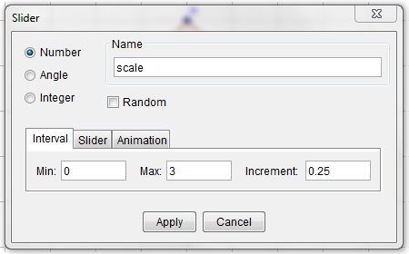
- Right click on the slider and unclick fix object and move to desired area.

- Select the arrow (the first square on the left) and click on the triangle you have created.

- Then select the arrow on reflect about line, the fourth box from the right, and click the last option dilate from point.
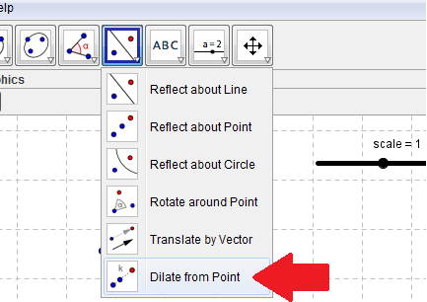
- Click anywhere on the grid (close to the circle) to make point to dilate from. Type in scale for the factor and press ok.
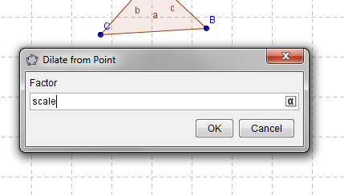
- Move the slider around and describe what happens to the triangle.

- When the slider is increased,

_____________________________________________________________________________________________
- When the slider is decreased,

_____________________________________________________________________________________________

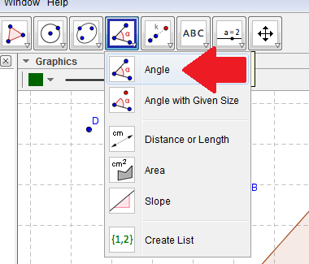
- Now, set the scale to 2.5 and click the arrow on angle, the fifth square from the right, and select the first option, angle.
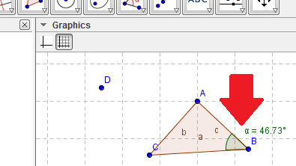
- After hitting the angle button, click the points A, B, C, in that order to find the angle ABC. Repeat for the second triangle using points A’, B’, and C’, to find the angle A’B’C’.

- Again repeat these steps to find angle BCA and angle B’C’A’.

- What do you notice about these angles?

_____________________________________________________________________________________________

_____________________________________________________________________________________________

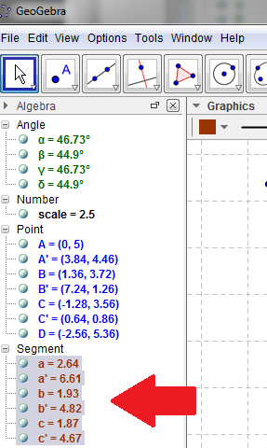
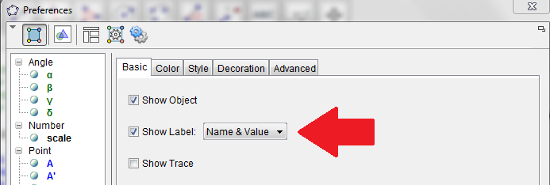
- On the left hand side, under the heading algebra, go down to the section labeled segments and select all of the segments by holding down the SHIFT key and pressing a through c’. Right click and select object properties. Check the box next to show label and in the drop down menu select name and value.
- After the side lengths all have visible measures, the ratios of the sides for the two triangles need to be compared. Look at the sides a and a’, b and b’, and c and c’.

- What do you notice about the ratios of these sides?

_____________________________________________________________________________________________

_____________________________________________________________________________________________

- What happens if you change the scale of the triangle in relation to the ratios?

_____________________________________________________________________________________________

_____________________________________________________________________________________________

EXTRA PRACTICE:
- If a triangle has side lengths of 4.5, 5.7, and 6.3 and a corresponding triangle is 3 times its size, what size would the corresponding triangle’s side lengths need to be?

Triangle 1 | Triangle 2
5
4.5
6.3

- Create two similar triangles. The second triangle should have sides and angles that correspond to the first triangle. Fill in the chart and write the difference in the scale between the two triangles. Use GeoGebra to create these triangles and check your work.

Scale: _________ | Triangle 1 | Triangle 2
Side 1
Side 2
Side 3
Angle 1
Angle 2
Angle 3

Help with GeoGebra from http://www.youtube.com/watch?v=VIFkiduO9fA

